Reference Main Model Architectures
Detailed analysis of augmentation, features, architecture blocks, input/output, protocol, and dataset-level results
Mục đích của file này
File này phân tích ba mô hình reference chính để làm nền học thuật cho phần 05 Main Model. Nội dung nhấn mạnh augmentation, feature engineering, kiến trúc, input/output, protocol đánh giá, rủi ro leakage và bài học có thể áp dụng vào đồ án.

1. Executive comparison
Paper/model | Core idea | Features | Augmentation | Reported results on project datasets | Protocol caveat
Ahmed et al. | 3 deep models plus weighted ensemble | MFCC, log-Mel/LMS, ZCR, chroma, RMS | AWGN, pitch shift, time stretch | TESS 99.46; RAVDESS 95.62; SAVEE 93.22; CREMA-D 90.47 | Strict speaker-aware split not clearly stated; augmentation leakage risk if split after augmentation.
Chowdhury et al. | 190 engineered features + stacked BiLSTM + DeepCRF | MFCC/delta/delta2/std, chroma, log-Mel, spectral contrast, energy, ZCR | Gaussian noise, pitch shift, time stretch | TESS 100; RAVDESS 97.83; SAVEE 97.02; CREMA-D 95.10; combined 93.76 | 80-20 and 5-fold; strict speaker-aware split not clearly stated.
Lee & Nadeem | MFCC 1D-CNN with channel/spatial attention | MFCC primary; Chroma ablation | Gaussian noise, pitch shift | TESS 99.82; RAVDESS 99.23; SAVEE 97.49; CREMA-D 89.31 | Single-dataset benchmark; strict speaker-aware split not clearly stated.

Ahmed et al. - Ensemble 1D-CNN-LSTM-GRU with Data Augmentation
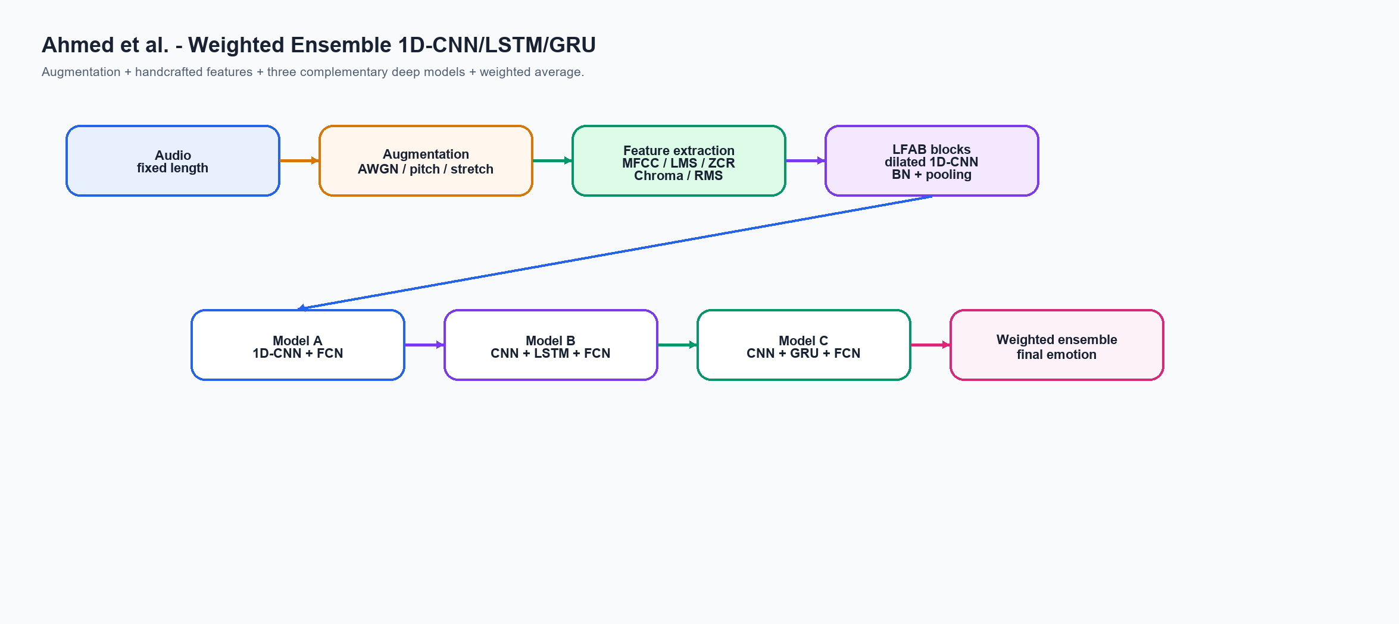
Ahmed et al.: augmentation + handcrafted features + three-model weighted ensemble.

Input and output
Input: Audio waveform resized to fixed length, augmented, then converted to handcrafted frame/clip features.
Output: Emotion class probabilities, then final emotion label. Reported labels vary by dataset; some papers include surprise/calm/boredom/EmoDB classes, so exact label space is not identical to our current six-label setup.

Feature engineering
MFCC, log Mel-scaled spectrogram, zero-crossing rate, chromagram, RMS/RMSE energy.

Augmentation strategy
Additive white Gaussian noise, pitch shifting, time stretching. The paper reports 3% to 32% improvement from augmentation.

Architecture blocks and functions
Block/algorithm | Function
Fixed-length audio | Normalize input duration so batched training is possible.
AWGN/pitch/time stretch | Increase training variation and reduce overfitting on small SER datasets.
Handcrafted features | Provide acoustic cues before deep learning: timbre, energy, pitch/harmonic, and spectral texture.
LFAB / dilated 1D-CNN | Extract local temporal patterns over feature sequence with wider receptive field.
LSTM or GRU branch | Capture long-term temporal dependencies beyond local CNN windows.
Weighted ensemble | Combine models A/B/C so complementary errors can cancel out.

Dataset-level reported results
Dataset | Reported accuracy (%)
TESS | 99.46
RAVDESS | 95.62
SAVEE | 93.22
CREMA-D | 90.47

Important caveat for our report
If augmentation is done before random split, augmented versions of the same original utterance may leak across train and test. The paper does not clearly describe group split by original utterance/speaker.

Chowdhury et al. - DCRF-BiLSTM Feature Engineering
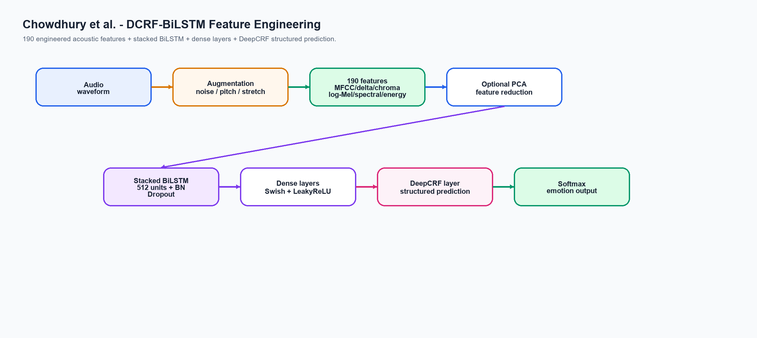
Chowdhury et al.: 190 engineered features + stacked BiLSTM + DeepCRF layer.

Input and output
Input: Audio waveform transformed into a 190-dimensional engineered feature representation.
Output: Emotion class probabilities, then final emotion label. Reported labels vary by dataset; some papers include surprise/calm/boredom/EmoDB classes, so exact label space is not identical to our current six-label setup.

Feature engineering
190 features: MFCC, delta, delta-delta, MFCC std, chroma STFT/CQT/CENS, log-Mel spectrogram, spectral contrast, energy/RMSE, ZCR. PCA optionally reduces features to around 82-97 dimensions depending on dataset.

Augmentation strategy
Gaussian noise at multiple levels, pitch shifting, and time stretching.

Architecture blocks and functions
Block/algorithm | Function
190 engineered features | Dense acoustic representation covering cepstral, spectral, chroma, energy and ZCR cues.
PCA optional | Reduce feature dimension while preserving most variance, lowering noise and model cost.
Stacked BiLSTM | Read feature sequence/context in both directions, learning temporal dependencies.
BatchNorm + Dropout + L2 | Stabilize training and reduce overfitting.
Dense + Swish/LeakyReLU | Nonlinear transformation to produce more separable emotion representation.
DeepCRF/CRF layer | Structured prediction layer that encourages consistent class decisions.

Dataset-level reported results
Dataset | Reported accuracy (%)
TESS | 100.00
RAVDESS | 97.83
SAVEE | 97.02
CREMA-D | 95.10
Combined | 93.76

Important caveat for our report
Very strong reported results, but split details do not establish strict speaker-aware or original-audio group split. Combined result also includes EmoDB, not exactly the same four-dataset setting as our current project.

Lee & Nadeem - MFCC 1D-CNN with Channel and Spatial Attention
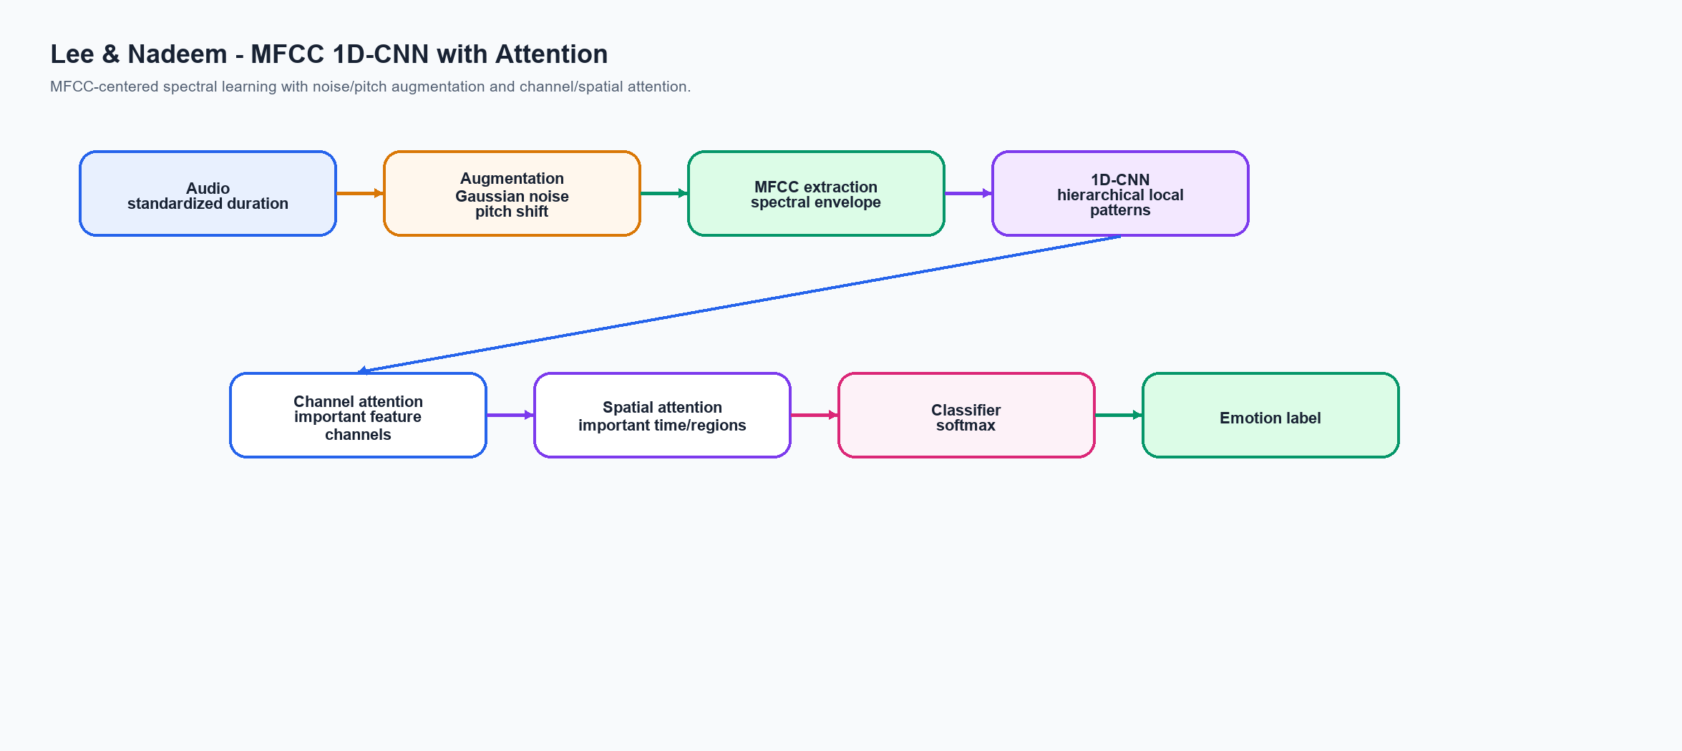
Lee & Nadeem: MFCC 1D-CNN enhanced by channel and spatial attention.

Input and output
Input: Audio waveform, augmented with noise/pitch, then represented as MFCC sequence/features.
Output: Emotion class probabilities, then final emotion label. Reported labels vary by dataset; some papers include surprise/calm/boredom/EmoDB classes, so exact label space is not identical to our current six-label setup.

Feature engineering
MFCC as main feature. Chroma is also evaluated but underperforms MFCC in their ablation.

Augmentation strategy
Gaussian noise with scale around 3.5% of max amplitude and pitch shifting by about +/-4 semitones.

Architecture blocks and functions
Block/algorithm | Function
Noise/pitch augmentation | Make MFCC patterns robust to speaker pitch and background perturbation.
MFCC extraction | Represent speech timbre and spectral envelope in a compact auditory-inspired feature space.
1D-CNN | Learn local discriminative patterns along MFCC/time dimension.
Channel attention | Learn which MFCC channels/features matter most for the current sample.
Spatial attention | Learn which temporal or feature regions deserve more weight.
Classifier head | Map attended CNN representation to emotion probabilities.

Dataset-level reported results
Dataset | Reported accuracy (%)
TESS | 99.82
RAVDESS | 99.23
SAVEE | 97.49
CREMA-D | 89.31

Important caveat for our report
Very large jump in ablation after MFCC+augmentation suggests augmentation and protocol are major contributors. No clear strict speaker-aware split is stated.

5. Glossary of technical terms
Term | Explanation for report/script
Data augmentation | Tạo thêm mẫu huấn luyện từ audio gốc bằng noise, pitch shift, time stretch. Mục tiêu là tăng variation và giảm overfit. Quan trọng: chỉ nên augment train set sau khi split để tránh leakage.
AWGN / Gaussian noise | Nhiễu trắng Gaussian cộng vào waveform. Nó buộc model học pattern cảm xúc bền hơn thay vì học tín hiệu quá sạch.
Pitch shifting | Dịch cao độ lên/xuống vài semitone nhưng giữ nội dung câu nói. Nó mô phỏng khác biệt speaker và ngữ điệu.
Time stretching | Kéo giãn hoặc nén tốc độ nói mà không đổi pitch quá nhiều. Nó mô phỏng tốc độ nói khác nhau.
MFCC | Mel-Frequency Cepstral Coefficients, đặc trưng mô tả spectral envelope/âm sắc theo thang nghe của con người.
Log-Mel spectrogram | Biểu diễn 2D thời gian-tần số. Trục ngang là thời gian, trục dọc là tần số Mel, giá trị là năng lượng log.
Chroma | Nhóm đặc trưng liên quan harmonic/pitch-class. Trong SER nó bổ sung thông tin về cấu trúc cao độ.
Spectral contrast | Đo chênh lệch giữa đỉnh và đáy phổ trong từng dải tần; hữu ích để mô tả độ sắc/texture của giọng.
RMS/RMSE energy | Đo năng lượng/cường độ nói. Emotion như angry/happy thường có energy khác sad/neutral.
ZCR | Zero Crossing Rate, số lần tín hiệu đổi dấu. Nó gợi ý độ gắt và voiced/unvoiced texture.
1D-CNN | Convolution theo một trục thời gian hoặc chuỗi feature. Nó học local pattern ngắn như đoạn tăng năng lượng hoặc đổi âm sắc.
LSTM/GRU/BiLSTM | Recurrent layers học phụ thuộc thời gian dài. BiLSTM đọc cả chiều tiến và lùi nên nắm được ngữ cảnh trước/sau frame.
Attention | Cơ chế học phần nào quan trọng hơn. Channel attention chọn kênh feature; spatial/temporal attention chọn vùng thời gian hoặc vùng feature quan trọng.
DeepCRF / CRF layer | Conditional Random Field mô hình hóa phụ thuộc giữa các nhãn/dự đoán lân cận. Trong SER, nó được dùng như structured prediction layer để làm dự đoán ổn định hơn.
Weighted ensemble | Kết hợp xác suất/dự đoán từ nhiều model bằng trọng số. Nếu model thành phần bổ sung nhau, ensemble thường tốt hơn từng model riêng.
Speaker-aware split | Chia train/test sao cho speaker ở test không xuất hiện trong train. Đây là split khó hơn random split và đánh giá generalization tốt hơn.
Augmentation leakage | Rủi ro khi augment trước split: audio gốc ở train, bản biến đổi của nó ở test. Khi đó test không còn độc lập và accuracy có thể tăng ảo.

6. What we should borrow for our next notebook
- Use train-only augmentation: noise, pitch shift and time stretch after splitting, never before splitting.
- Build a paper-comparable random augmented setting, but also keep strict no-leakage setting for academic honesty.
- Upgrade engineered features toward Chowdhury-style 190 features and optionally PCA.
- Add CNN-LSTM/CNN-GRU or CNN-BiLSTM branches and compare with current temporal CNN-BiGRU-attention branch.
- Use adaptive ensemble: choose weights by validation per protocol/dataset, and allow best-branch selection when ensemble hurts.

7. Sources
Ahmed et al. 2021: An Ensemble 1D-CNN-LSTM-GRU Model with Data Augmentation for Speech Emotion Recognition. https://arxiv.org/abs/2112.05666
Chowdhury et al. 2025: A Novel Hybrid Deep Learning Technique for Speech Emotion Detection using Feature Engineering. https://arxiv.org/abs/2507.07046
Lee & Nadeem 2025: Toward Efficient Speech Emotion Recognition via Spectral Learning and Attention. https://arxiv.org/abs/2507.03251

